Blinkit Sales Analysis
SQL Project — Query Documentation
Abhishek Nirmal | github.com/abhisheknirmal02-lab
Dataset: Blinkit Retail Sales | Tool: PostgreSQL / MySQL

SECTION 1 : DATA CLEANUP

Q1. Standardise Item Fat Content values
Normalises inconsistent entries (LF, low fat -> Low Fat; reg -> Regular)
UPDATE retail_sales
SET item_fat_content =
CASE
WHEN item_fat_content IN ('LF','low fat') THEN 'Low Fat'
WHEN item_fat_content = 'reg' THEN 'Regular'
ELSE item_fat_content
END;
[ Screenshot — Before / After Fat Content standardisation ]
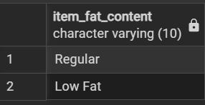

SECTION 2 : KPI OVERVIEW (All Years)

Q2. Total Sales (Millions)
Grand total revenue across all outlets and years
SELECT CAST(SUM(sales) / 1000000 AS DECIMAL(10,2)) AS Total_Sales_Millions
FROM retail_sales;
[ Screenshot — Total Sales Millions ]
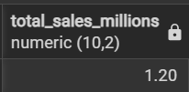

Q3. Average Sales per Item
SELECT CAST(AVG(sales) AS DECIMAL(10,1)) AS Avg_Sales
FROM retail_sales;
[ Screenshot — Average Sales ]
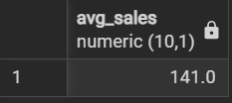

Q4. Total Number of Items
SELECT COUNT(*) AS No_of_Items
FROM retail_sales;
[ Screenshot — Total Item Count ]
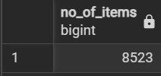

Q5. Average Customer Rating
SELECT CAST(AVG(rating) AS DECIMAL(10,2)) AS Avg_Rating
FROM retail_sales;
[ Screenshot — Average Rating ]
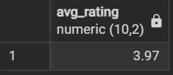

SECTION 3 : KPI OVERVIEW (Year Filter — 2022)

Q6. Total Sales — 2022
SELECT CAST(SUM(sales) / 1000000 AS DECIMAL(10,2)) AS Total_Sales_Millions
FROM retail_sales
WHERE outlet_establishment_year = 2022;
[ Screenshot — Total Sales 2022 ]
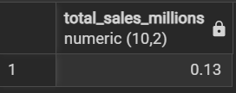

Q7. Average Sales — 2022
SELECT CAST(AVG(sales) AS DECIMAL(10,1)) AS Avg_Sales
FROM retail_sales
WHERE outlet_establishment_year = 2022;
[ Screenshot — Average Sales 2022 ]
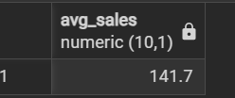

Q8. Total Items — 2022
SELECT COUNT(*) AS No_of_Items
FROM retail_sales
WHERE outlet_establishment_year = 2022;
[ Screenshot — Item Count 2022 ]
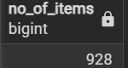

SECTION 4 : OUTLET ANALYSIS

Q9. KPIs by Outlet Establishment Year
Yearly breakdown of total sales, avg sales, item count, and avg rating
SELECT
outlet_establishment_year,
CAST(SUM(sales) AS DECIMAL(10,2)) AS Total_Sales,
CAST(AVG(sales) AS DECIMAL(10,1)) AS Avg_Sales,
COUNT(*) AS No_of_Items,
CAST(AVG(rating) AS DECIMAL(10,2)) AS Avg_Rating
FROM retail_sales
GROUP BY outlet_establishment_year
ORDER BY Total_Sales DESC;
[ Screenshot — KPIs by Outlet Year ]
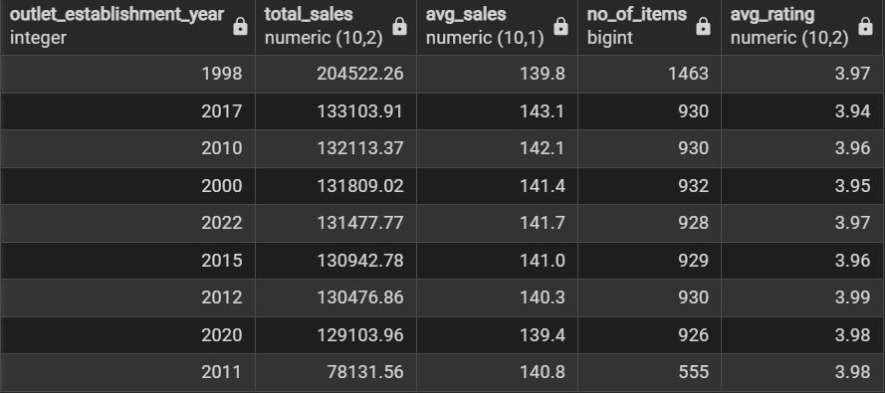

Q10. Sales Trend by Year (Chronological)
Used for line/area chart — ordered by year ascending
SELECT
outlet_establishment_year,
CAST(SUM(sales) AS DECIMAL(10,2)) AS Total_Sales
FROM retail_sales
GROUP BY outlet_establishment_year
ORDER BY outlet_establishment_year ASC;
[ Screenshot — Sales Trend by Year ]
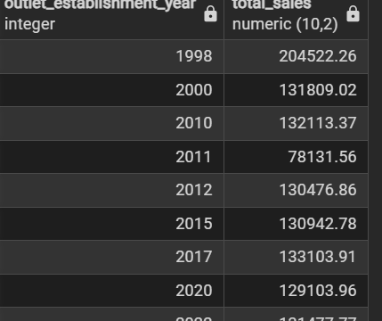

Q11. Sales & Share by Outlet Size
Window function calculates each size's % contribution to total sales
SELECT
outlet_size,
CAST(SUM(sales) AS DECIMAL(10,2)) AS Total_Sales,
CAST((SUM(sales) * 100.0 / SUM(SUM(sales)) OVER()) AS DECIMAL(10,2)) AS Sales_Percentage
FROM retail_sales
GROUP BY outlet_size
ORDER BY Total_Sales DESC;
[ Screenshot — Sales % by Outlet Size ]
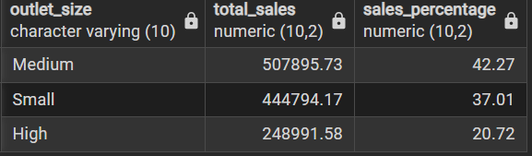

Q12. KPIs by Outlet Location Type (2022)
SELECT
outlet_location_type,
CAST(SUM(sales) AS DECIMAL(10,2)) AS Total_Sales,
CAST((SUM(sales) * 100.0 / SUM(SUM(sales)) OVER()) AS DECIMAL(10,2)) AS Sales_Percentage,
CAST(AVG(sales) AS DECIMAL(10,1)) AS Avg_Sales,
COUNT(*) AS No_of_Items,
CAST(AVG(rating) AS DECIMAL(10,2)) AS Avg_Rating
FROM retail_sales
WHERE outlet_establishment_year = 2022
GROUP BY outlet_location_type
ORDER BY Total_Sales DESC;
[ Screenshot — KPIs by Location Type 2022 ] 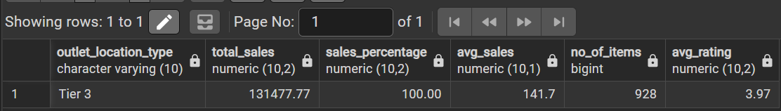

Q13. KPIs by Outlet Type
Supermarket Type 1/2/3 vs Grocery Store breakdown
SELECT
outlet_type,
CAST(SUM(sales) AS DECIMAL(10,2)) AS Total_Sales,
CAST((SUM(sales) * 100.0 / SUM(SUM(sales)) OVER()) AS DECIMAL(10,2)) AS Sales_Percentage,
CAST(AVG(sales) AS DECIMAL(10,1)) AS Avg_Sales,
COUNT(*) AS No_of_Items,
CAST(AVG(rating) AS DECIMAL(10,2)) AS Avg_Rating
FROM retail_sales
GROUP BY outlet_type
ORDER BY Total_Sales DESC;
[ Screenshot — KPIs by Outlet Type ]
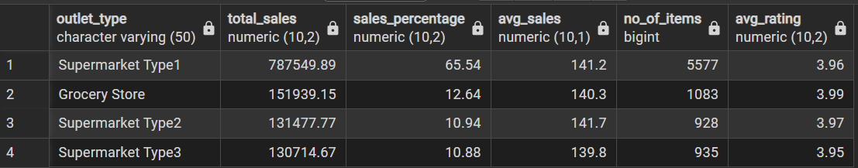

SECTION 5 : ITEM FAT CONTENT ANALYSIS

Q14. Total Sales by Fat Content
SELECT
item_fat_content,
CAST(SUM(sales) AS DECIMAL(10,2)) AS Sales
FROM retail_sales
GROUP BY item_fat_content
ORDER BY Sales DESC;
[ Screenshot — Sales by Fat Content ]
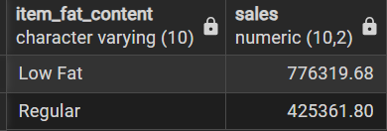

Q15. Full KPIs by Fat Content (All Years)
SELECT
item_fat_content,
CAST(SUM(sales) AS DECIMAL(10,2)) AS Total_Sales,
CAST(AVG(sales) AS DECIMAL(10,1)) AS Avg_Sales,
COUNT(*) AS No_of_Items,
CAST(AVG(rating) AS DECIMAL(10,2)) AS Avg_Rating
FROM retail_sales
GROUP BY item_fat_content
ORDER BY Total_Sales DESC;
[ Screenshot — Full KPIs by Fat Content ]
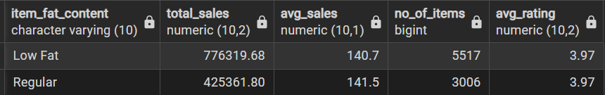

Q16. Fat Content KPIs — 2022 (Sales in Thousands)
SELECT
item_fat_content,
CAST(SUM(sales) / 1000 AS DECIMAL(10,2)) AS Total_Sales_Thousands,
CAST(AVG(sales) AS DECIMAL(10,1)) AS Avg_Sales,
COUNT(*) AS No_of_Items,
CAST(AVG(rating) AS DECIMAL(10,2)) AS Avg_Rating
FROM retail_sales
WHERE outlet_establishment_year = 2022
GROUP BY item_fat_content
ORDER BY Total_Sales_Thousands DESC;
[ Screenshot — Fat Content KPIs 2022 ]
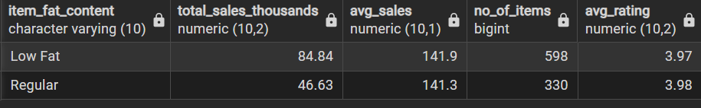

Q17. Fat Content Sales Pivot by Location Type (CASE WHEN)
Low Fat vs Regular sales side-by-side per location tier
SELECT
outlet_location_type,
SUM(CASE WHEN item_fat_content = 'Low Fat' THEN sales ELSE 0 END) AS Low_Fat,
SUM(CASE WHEN item_fat_content = 'Regular' THEN sales ELSE 0 END) AS Regular
FROM retail_sales
GROUP BY outlet_location_type
ORDER BY outlet_location_type;
[ Screenshot — Fat Content Pivot by Location (CASE WHEN) ]
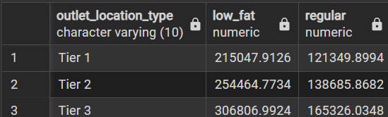

Q18. Fat Content Sales Pivot by Location Type (FILTER clause)
Same pivot using PostgreSQL FILTER syntax — cleaner alternative
SELECT
outlet_location_type,
SUM(sales) FILTER (WHERE item_fat_content = 'Low Fat') AS Low_Fat,
SUM(sales) FILTER (WHERE item_fat_content = 'Regular') AS Regular
FROM retail_sales
GROUP BY outlet_location_type
ORDER BY outlet_location_type;
[ Screenshot — Fat Content Pivot by Location (FILTER) ]
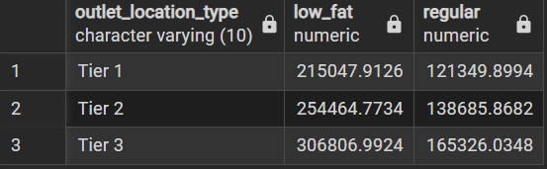

Q19. KPIs by Location + Fat Content (Combined Grouping)
SELECT
outlet_location_type,
item_fat_content,
CAST(SUM(sales) AS DECIMAL(10,2)) AS Total_Sales,
CAST(AVG(sales) AS DECIMAL(10,1)) AS Avg_Sales,
COUNT(*) AS No_of_Items,
CAST(AVG(rating) AS DECIMAL(10,2)) AS Avg_Rating
FROM retail_sales
GROUP BY outlet_location_type, item_fat_content
ORDER BY Total_Sales ASC;
[ Screenshot — KPIs by Location + Fat Content ]
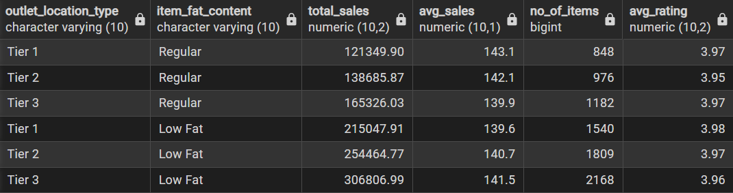

SECTION 6 : ITEM TYPE ANALYSIS

Q20. KPIs by Item Type (All Years)
Full breakdown across all product categories
SELECT
item_type,
CAST(SUM(sales) AS DECIMAL(10,2)) AS Total_Sales,
CAST(AVG(sales) AS DECIMAL(10,1)) AS Avg_Sales,
COUNT(*) AS No_of_Items,
CAST(AVG(rating) AS DECIMAL(10,2)) AS Avg_Rating
FROM retail_sales
GROUP BY item_type
ORDER BY Total_Sales DESC;
[ Screenshot — KPIs by Item Type All Years ]
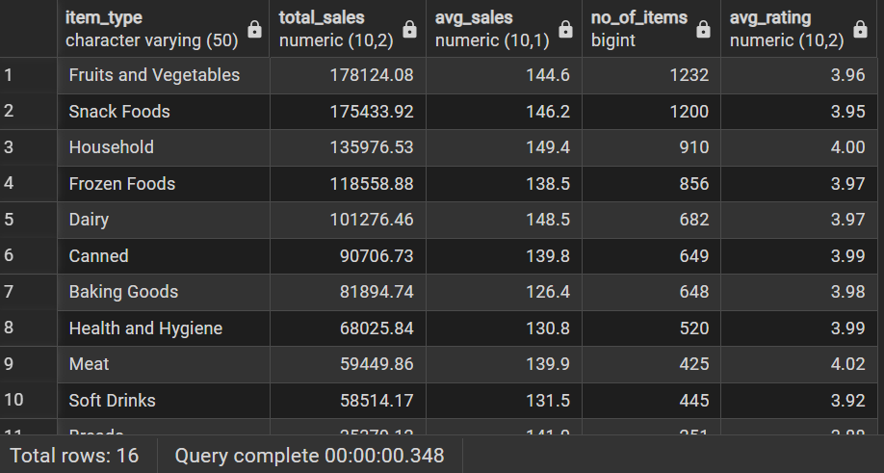

Q21. Top 5 Item Types by Sales — 2022
LIMIT 5 surfaces the top-performing categories in the most recent year
SELECT
item_type,
CAST(SUM(sales) AS DECIMAL(10,2)) AS Total_Sales,
CAST(AVG(sales) AS DECIMAL(10,1)) AS Avg_Sales,
COUNT(*) AS No_of_Items,
CAST(AVG(rating) AS DECIMAL(10,2)) AS Avg_Rating
FROM retail_sales
WHERE outlet_establishment_year = 2022
GROUP BY item_type
ORDER BY Total_Sales DESC
LIMIT 5;
[ Screenshot — Top 5 Item Types 2022 ]
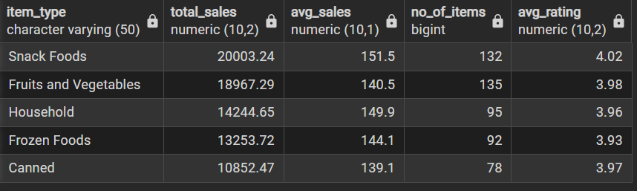

Q22. KPIs by Location Type + Item Type (Combined)
Cross-dimension analysis — which item types sell best in Tier 1/2/3 locations
SELECT
outlet_location_type,
item_type,
CAST(SUM(sales) AS DECIMAL(10,2)) AS Total_Sales,
CAST(AVG(sales) AS DECIMAL(10,1)) AS Avg_Sales,
COUNT(*) AS No_of_Items,
CAST(AVG(rating) AS DECIMAL(10,2)) AS Avg_Rating
FROM retail_sales
GROUP BY outlet_location_type, item_type
ORDER BY Total_Sales DESC;
[ Screenshot — KPIs by Location + Item Type ]
